OPERATING SYSTEMS

Operating system allows the communications between hardware of the computer and a user.
It allows a user to run programs and applications.

Using of OS
Desktop
includes personal computers (PCs, AIOs - All in One computers, laptops). The aim of the system is to offer simplicity and work with many applications. The most well-known operating systems for desktop computers are Microsoft Windows, MacOS from Apple and Linux.
Server
The aim of the system is to offer high computing power, easy maintenance, resistance to computer attacks, the ability to modify the system and scaling. The most used systems include Linux and Windows server distributions.

Mobile devices
There are more mobile devices than traditional desktop computers these days, that´s why OS such as Android and iOS were developed. The goal of the system for mobile devices is simplicity and saving battery power.

Real-Time
special type of operating systems. Used for example in cars, security systems or routers.

Functions of OS
Hardware control
- You need drivers to communicate between the hardware and operating system
- Operation system uses drivers to ensure a correct operation of each device
- Everything you connect to your computer relies on drivers to work correctly
Application management
- Operating system allocates system resources to an application
- Operating system allocates a certain amount of ram or disk space to each application
User interface
- User interface is one of the main parts of an operating system
- It allows a user to enter and receive information
We can divide user interfaces to two groups: graphical and command line based.
  - Graphical (GUI) – user can interact with windows, apps, icons and use mouse to navigate
  - Command line based (CLI) – user interact with text only, uses commands to do different tasks

Parts of OS
Kernel
The kernel is the part of the operating system that performs the basic, lowest-level tasks. These are mainly memory operations such as memory allocation, allocation of CPU computing time, and several input and output operations. The kernel then communicates with other layers, modules or superstructures that already communicate directly with the user.
Memory management
Memory management is a function responsible for managing the computer's primary memory. The main aim of memory management is to achieve efficient utilization of memory. It checks how much memory needs to be allocated to each process.
File management
It is a process of creating an organized structure in which you store information. Users can create folders that accommodate their method of organization. File management increases efficiency by reducing the time employees require to find documents. It is a type of software that manages data files in a computer system.
Input & output
is the communication between an information processing system, such as a computer, and the outside world, possibly a human or another information processing system. Inputs are the signals or data received by the system and outputs are the signals or data sent from it.

Input – mouse, keyboard, microphone
Output – monitor, speaker

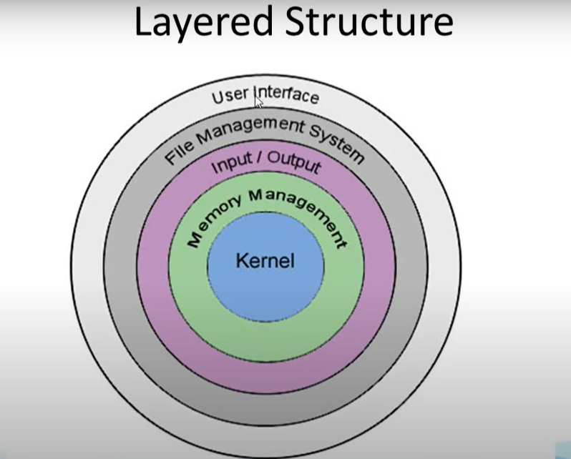

Windows
is Microsoft’s OS family. It is the most used OS in the world. Windows is closed-source OS. We have lots of window’s versions, e. g. Windows 7, 8, 8.1, 10, 11 or its server distributions e. g. Windows Server 2016, 2019. Windows is popular because of its intuitive and simple designed GUI. It also supports 3D graphics used in games or computer graphics.

UNIX
It is an old system, but lots of today’s OS were built on its principle. It is multitasking and multi-user OS designed for mainframes and workstations. It is written in C programming language.
LINUX
is UNIX based OS. Linux is open-source system with CLI (Command line Interface) and GUI (Graphics user interface) UI (User-Interface). Everybody can change their LINUX distribution system to its own form. We know
a lot of distributions of LINUX e. g. Ubuntu, Debian, Kali, CentOS and many more.
ANDROID
is LINUX-based OS made for mobile devices and touch-screen devices. It is recently the most used OS in phones, televisions and other smart devices.
IOS
is Unix-based OS developed by Apple .Inc for their mobile devices. It is closed-source OS.
MAC OS
is Unix-based OS for Apples personal computers. It is closed-source OS.

